Lab 4
Program to Implement the Concept of Default, Parameterized
and Static Constructor

Objective
To understand how constructors work in C# including Default Constructor, Parameterized Constructor, and Static Constructor.

Approach
A constructor in C# is a block of code similar to a method that’s called when an instance of an object is called. Every class has a constructor even if you don’t define it. This is called default constructor. The default constructor is no longer used after you define your own constructor. The default constructor has no parameters and is used to initialize objects with default values. A parameterized constructor in C# is a constructor that takes arguments (parameters) to initialize an object with custom values when it's created. A static constructor is a constructor called before instance of an object is created.
In this lab session, a C# program having a default constructor, parameterized constructor and static constructor was created. A static constructor is called automatically to initialize the class before the first instance is created. Default constructor is called when the constructor has no parameters and used to initialize objects with default values and parameterized constructor is called to initialize objects with custom values.

Results
The following source code show the uses of different types of constructor in C#.
namespace SmritiShrestha.src.SessionFour;
using System;
class Product
{
public string Name;
public string Category;
public double Price;
public int StockQuantity;

static Product()
{
Console.WriteLine("Static constructor called.");
}
public Product()
{
Name = "Unknown";
Category = "General";
Price = 0.0;
StockQuantity = 0;
}

public Product(string name, string category, double price, int stockQuantity)
{
Name = name;
Category = category;
Price = price;
StockQuantity = stockQuantity;
}
public void DisplayProduct()
{
Console.WriteLine($"Name: {Name}, Category: {Category}, Price: {Price:F2}, StockQuantity: {StockQuantity}");
}
}
class Program
{
static void Main(string[] args)
{
Product myProduct1 = new Product();
myProduct1.DisplayProduct();
Product myProduct2 = new Product("Laptop", "Electronics", 999.99, 10);
myProduct2.DisplayProduct();
}
}
Explanation:
This C# program contains a class named product with four fields: Name, Category, Price and Stock Quantity. There is a static constructor that runs only once before any new instance is created, a default constructor that sets all fields to default values like "Unknown", “General” and 0, and a parameterized constructor that allows you to set custom values for a product when creating it. There is also a method called DisplayProduct() that prints out the product's details in a formatted way.

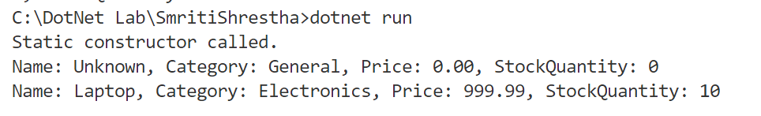
Fig 1: Output of the above Program

Upon execution, the following observations were made:
- Static constructor: This constructor is called before any instance is created. It runs only once and displays a message to the console.
- Default constructor: This constructor is called when the constructor has no parameters. It initializes the fields with default values like ‘Unknown’ for Name, ‘General’ for category and ‘0’ for price and stock quantity.
- Parameterized Constructor. This constructor is called when the constructor takes specific values as parameters. It assigns the fields with those values.

Conclusion
This lab session successfully demonstrated the use of different types of constructors in C#, each serving a specific purpose. The static constructor is used for one-time execution when the class is first accessed. The default constructor allows the creation of objects with predefined values, while the parameterized constructor enables the creation of more flexible and customized objects. Together, these constructors provide multiple ways to initialize objects, making the class more versatile and practical for real-world applications.

